This draft is for discussion only in the context of presentations at the AALS Works-In-Progress and should not be cited. It accompanies joint presentations:

“Rethinking Individuality” (See separate abstract) - Dr. Gregory Todd Jones - Presenter

“A Natural History of Conflict Resolution” (Abstract below) - Professor Douglas Yarn- Presenter

Consortium on Negotiation and Conflict Resolution, College of Law, Georgia State University
Prepared for the AALS Dispute Resolution Section 2009 Works-in-Progress Conference, November 13-14, 2009, Boston, MA.

A Natural History of Conflict Resolution

Abstract

In this work, we develop a naturalistic treatment of conflict resolution mechanisms, both biological and institutional, in the context of the increasing complexity that characterizes our evolutionary history. In an effort to understand mechanisms such as apology, forgiveness, and reconciliation - behaviors that can be shown to have significant adaptive value - we begin with an examination of individual behavior. We then employ evolutionary biology and game theory to illustrate how the strategic dynamics of dyadic interaction tend to favor these behaviors and derive a schema relevant to a reconciliatory cycle. Finally, we explore how group membership and group-based conflicts may influence individual strategic choice, particularly in relation to particular social architectures and most particularly those that differ from the ancestral social architecture within which individual cognitive capacity evolved.

Background

Founded as one of the Hewlett-founded theory-building centers in 1987, the Consortium has had a long-standing interest in how behavioral biology informs conflict resolution. Our relationship with Yerkes Primate Research Institute predates the Consortium, and since 1994, we have worked closely with the Gruter Institute on Law and Human Behavior. Although we have long advocated the integration of more hard sciences, particularly biology, into conflict resolution theory and teaching, our opportunity to do so came in 2004 when Hewlett decided to close its conflict resolution program.

After announcing its intention to cease funding in the field, Hewlett asked Professor Robert Baruch-Bush of Hofstra law school to report on what crucial areas had yet to be explored by the theorists. During his spate of interviews with us and other theory-building centers to produce his “knowledge gaps” report, we made the point that the field had mostly ignored the so-called “hard sciences,” particularly behavioral biology. During a follow-up meeting in Washington, DC, the directors of the various theory-building centers agreed. In response and as one of its last contributions to the field, the Foundation provided us with a seed grant to study what we referred to as the “nexus” of conflict resolution and biology.

In the ensuing years, we met with scientists of all stripes, from biologists to neuroethologists. We’ve struggled through hundreds of papers from unfamiliar academic disciplines and even started our own original line of research in theoretical biology using computer-simulated game theory. While there is still much to do, and we have barely scratched the surface of the nexus, we think that the time is ripe to initiate a conversation about what we’ve learned so far.

This conversation is important because the study of conflict resolution needs a more robust, unifying theoretical foundation. The accumulated body of multidisciplinary knowledge for the field is impressive and has yielded useful practice applications. Unfortunately, conversation across these disciplines remains stilted and true cross-disciplinary perspectives are limited. More than a decade ago, we attempted to address this problem through synthesis. We compiled a lexicon, The Dictionary of Conflict Resolution (Jossey-Bass 1999), containing definitions of commonly used terms in the field from various disciplinary perspectives and suggesting definitions that transcended contributing disciplines. In retrospect, we realize that the problem is much deeper. E. O. Wilson describes it as a need for “consilience,” agreement on “a common body of abstract principles and evidentiary proof.” In short, it’s not merely a problem of language but also one of conceptual unity.

We think that behavioral biology and the emerging science of complexity has a fundamental role to play in creating this conceptual unity. While conflict resolution has been establishing itself as a field, there have been extraordinary advances in the biological sciences. Evolutionary theory is helping to better explain the ultimate causes of pro-social behaviors, the building blocks of conflict resolution. Meanwhile, the proximate causes of these behaviors are increasingly revealed by technological breakthroughs in the neurosciences providing a window on brain and neuro-chemical functions.

Although biology has always had much to offer, social scientists largely shunned or ignored its possible contributions until recently either because of entrenched disciplinary dogma that pitted biological against cultural explanations for human behavior or because of the taint of eugenics and other misuses of evolutionary theory. But this resistance is quickly fading. Today, many biologists and social scientists have come to understand nature and nurture as complimentary rather than dichotomous concepts. As a result, more researchers are turning to the nexus of biology and other disciplines. For example, some economists, including recent Nobel Prize winner Dr. Vernon L. Smith, are establishing the study of “neuroeconomics.” In law, the Gruter Institute for Law and Human Behavior and the Society for Evolutionary Analysis in Law examine the relationship of biology to legal behaviors. In psychology, researchers such as the late Dr. James Dabbs and McArthur genius award winner, Robert Sapolsky, have clarified the relationships between hormones such as testosterone, cortisol, and oxytosin to stress, well-being, pro and anti-social behaviors, and occupational preference. Whole philosophy departments are embracing neuroimaging as a window into reason. Even in the arts, a new field of “neuroesthetics” is emerging from an increased understanding of the neurological causes of aesthetic feelings and the artistic sense.

Despite this interdisciplinary nexus breakthrough in other areas, very few researchers have explored the nexus of biology and CR. Teams at Princeton and Emory have used neuro-imaging technology to study the neural basis for social cooperation, and a Penn and Claremont collaboration has found that oxytocin levels are a strong predictor of trust and trustworthiness, while cortisol and testosterone are weaker predictors. All of these researchers work independently of the CR field, and few CR theorists are familiar with their work or have integrated biological approaches. In short, the nexus of biology and conflict resolution is a promising area that has been minimally explored; however, there is growing interest, if the titles of breakout sessions at various CR conferences are an indicator.

We are now working on a book that, hopefully, weaves together the many theoretical strands with which we have been working to clarify the nexus. This is the first time we have presented some of the Nexus Project work to a gathering of law professors specializing in CR. Together with Dr. Jones’ presentation, this presentation gives an overview of the state of our effort by describing the developmental stages of our work.

First Stage – The Social Brain in Diadic Intra-group Conflict

The first stage of our work is best summarized by our chapter entitled Negotiation Is In Our Bones (Or Brains): Behavioral Biology As A Basis For Understanding, in the ABA’s “Negotiator’s Fieldbook,” edited by Andrea Schneider and Chris Honeyman. At that point, we were focused primarily on the brain and its realtionship to the seemingly irrational human behaviors and emotions that undermine the rational problem-solving approach, popularized and typified by “Getting to Yes.”

Conflict resolution relies on an understanding of human behavior. As we note in our chapter cited above:
At its most fundamental level, human behavior is a biological phenomenon, because, ultimately, all theories about human behavior are theories about the brain—an organ operating on physical principles that receives stimuli, makes computations, and directs behavioral outputs. Far from being an all-purpose computer or “blank slate,” the brain has been shaped over millions of years by evolutionary forces producing a species-typical brain that produces species-typical behavioral outputs in response to various stimuli. When modern homo sapiens appeared, approximately 100,000 years ago, our brains were pretty much as they are now—adapted to meet the challenges of life in an ancestral environment that biologists refer to as the “environment of evolutionary adaptation” (the “EEA”). The EEA was both a physical and social environment the challenges of which might be boiled down to food choice (eating), predator avoidance (survival), and mate selection (reproduction). If it is common for humans to exhibit a given behavior today, then the predisposition to behave that way may have enhanced survival and reproduction over time in the EEA. (Footnotes omitted)

The punch line here is that there hasn’t been sufficient time for major evolutionary changes in the human brain; therefore, we have a mostly Paleolithic mind in a post-modern age, and behavior that seems irrational in the present environment may be perfectly rational when considered in the context of the EEA. This mismatch between our ancestral evolved brains and the present day environment may explain the various heuristics, biases, and emotions that seem to irrationally depart from the model of homo economicus decision making.

In biological terms, organisms are driven to increase their reproductive fitness relative to that of others, and in this sense, organisms are competitive at their foundations, essentially, the “selfish gene.” During the EEA, our ancestors formed cooperative groups to improve their reproductive fitness. How was this possible in light of our inherent self-regard? Evolutionary game theory helps reveal the conditions under which the benefits of group living promote more reproductive success than solitary living. Despite its benefits, group living also creates opportunity for more conflict among group members and for free riding; therefore, successful group living required behaviors that promoted cooperative, altruistic behavior and discouraged free riding by group members. Although Axelrod is best known to the CR field, many biological theorists have used game theory in attempting to explain the evolution of cooperation among non-kin in nature. In our own game theory modeling, we and others have concluded that the optimal strategy in this context is tit-for-tat with forgiveness. Tactical social behaviors that roughly match and support this reciprocal strategy are trust, the ability to judge fairness, vengefulness, and forgiveness. Emerging evidence of proximate causation revealed in neurochemistry and neuro-imaging support this theory of ultimate causation, together with ethnographic studies and ethology, particularly observations of other social species.

We concluded in the above-referenced chapter:
The central message is not a particularly astounding one: Successful social interaction generally, and negotiation more specifically, requires a finely tuned understanding of other people’s intentions and actions. Behavioral biology teaches us that we have evolved brains that are usually pretty accurate in unconsciously making such calculations. Nevertheless, a more conscious understanding of the biology underlying negotiating behaviors may help us anticipate some behaviors and develop strategies to influence cooperative negotiating behaviors. Above all, we should not lose sight of the fact that the neuroanatomy that accounts for adaptive behaviors and emotions involving competition and cooperation has been selected over millions of years with survival of the species as the only objective. Far from being pathological deviations from the traditional model of rational decision-making, these are shared characteristics that account for who we are and define our nature as human beings.

As we transitioned from this stage of the Nexus Project, we developed an evolutionary biology theory of reconciliation (or return to cooperation), which we deem to be the most fundamental objective of conflict resolution behaviors. We expressed this in the following schema:

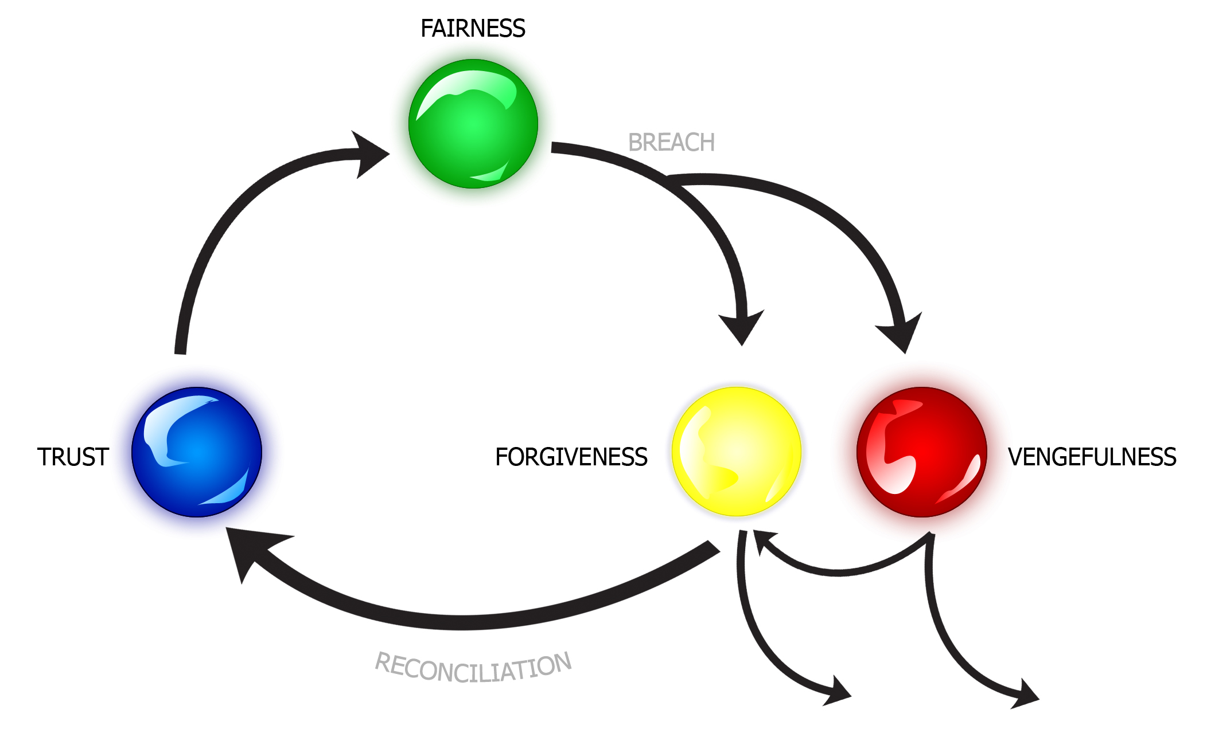

The behaviors and related emotions that arise in conflict and its resolution evolved within small groups in order to manage intra-group conflict and cooperation. The effectiveness of these behaviors relied on repeated encounters or the anticipation of repeat encounters, and in that context, such behaviors are “rational,” despite not depending on the cerebral cortex, but are seemingly irrational outside of that context. This brought us to the next stage in which we attempted to address the following compound question: How does behavioral biology inform us when the conflict is between groups or when the social architecture shifts away from small bands to large groups of potentially anonymous non-repeat players?

Second Stage – Inter-Group Conflict and Changes in Social Architecture

This stage is probably best summarized in our recently published article entitled A Biological Approach to Understanding Resistance to Apology, Forgiveness, and Reconciliation in Group Conflict, 72 L. & Contemp. Prob. 63 (2009). We wrote the article in early 2007 for a conference at Vanderbilt on barriers to reconciliation between groups. By “reconciliation,” we mean both the restoration of cooperative relations after estrangment and the establishment of cooperative relations between persons, either individuals or groups, who have been at variance without regard to whether they have had a prior cooperative relationship.

We started with the following assertion: reconciliation, even in inter-group conflict, takes place at the level of the individual organism. To understand resistance to group reconciliation, one must understand why individuals resist reconciliation. In turn, one must understand how membership in the group affects individual resistance. While evolutionary biology and game theory provide an explanation of how the strategic dynamics of dyadic interaction within a group tend to favor the behaviors involved in conflict and reconciliation—trust, fairness discernment, vengefulness, and forgiveness; it also explains prejudicial and xenophobic behaviors that could result from dyadic interactions between individuals belonging to different groups potentially vying for the same resources.

Despite competitive tensions between groups in the EEA, there was selective pressure to form larger groups through fussion and assimilation. Our computational models show how increased levels of integration initially aggrevate and then reduce prejudicial behaviors and promote cooperation in the larger group. In turn, change in social group size and architecture posed additional conflict management problems creating selective pressures possibly contributing to the development of language, a larger cerebral cortex, higher sensitivities to non-verbal signalling, and the cultural construct of social institutions, among other things.

At this point, our own computational models combining network theory with game theory were beginning to raise some interesting questions about barriers to individual reconciliation resulting from the strategic dynamics of social group architectures that differed from the ancestral social architecture within which individual behavior evolved.

The social environment, in which we now live, has changed dramatically from the EEA. The small, regularly-connected social networks of the EEA are being replaced by extremely large scale-free networks where a very few individuals remain highly connected, but where the vast majority of individuals lead largely unconnected, anonymous lives. (See Figure x).

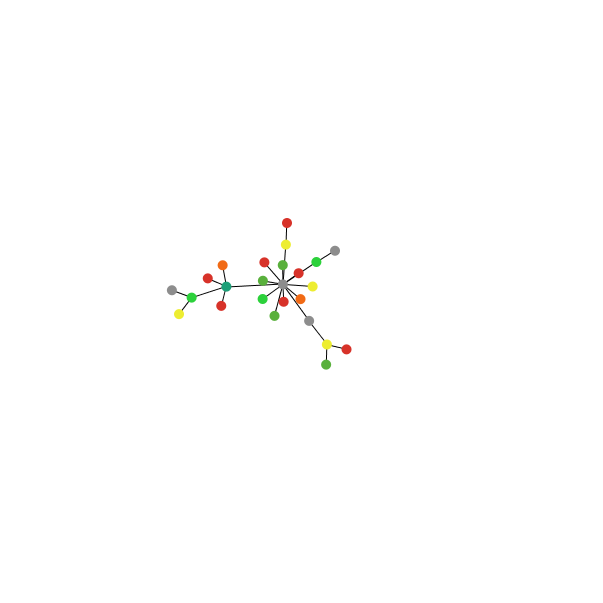
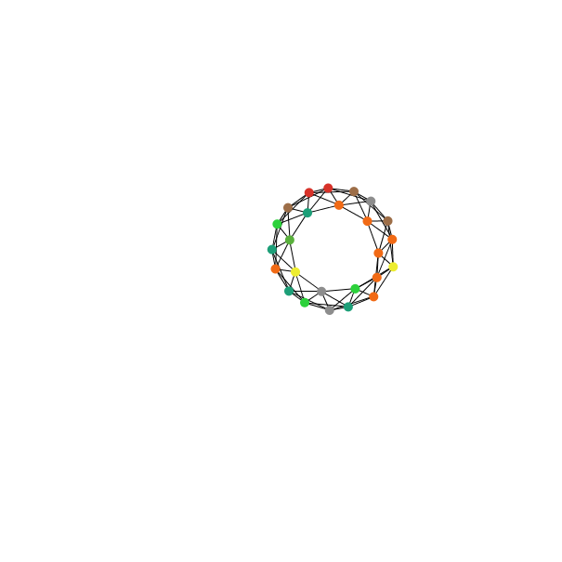
A
B

Figure XX: A: A regularly-connected, degree-homogeneous network representative of what may have been typical of the EEA. B: A scale-free, degree-heterogeneous network representative of the modern age. Note: For illustrative purposes, the structure of the network and explicitly not the group size is representative.
(For full color illustrations and more detailed supplemental material, see http://www.cncrnet.org/nexus/yarnandjoneslcpsupplemental.pdf.)

Quoting from the article:
Social architecture matters. Average degree (the number of connections an individual shares with others in the social network) and heterogeneity of degree, for example, can have dramatic effects on the prevalence of pro-social behavior in large groups. Our research on evolutionary dynamics in networks demonstrates that a certain level of degree is necessary in order for reciprocal cooperation to arise, but that when degree becomes large relative to population size, such reciprocity suffers. Further, our simulations show that reciprocal strategies that promote cooperation in the degree-homogeneous, regularly-connected social networks typical of the EEA are not as successful in doing so in the degree-heterogeneous networks of the modern age.

We’ve also noted certain “threshold effects” in which small changes in the social architecture, the addition of a particular individual, for example, can result in significant non-linear changes or phase transitions resulting in large-scale collective action. Moreover, again quoting:
...specific individuals may be more likely to bring about a cascade of collective action than others. When the evolved mechanisms of our species-typical brain fall short in the modern environment, we depend on the design of targeted institutions to fill the gap, and certain individuals are more relevant to this task. Certainly, the identification of these relevant individuals is not an easy task, but our recent simulations demonstrate that it is possible. The sparse culling of only a few relationships can result in network effects that spread reciprocal cooperation throughout the network.

Similarly, the creation of only a few relationships can result in network effects that spread reciprocal cooperation throughout the network. Timing of intervention and the level of network equilibrium have also proved important.

As we concluded this stage of the Nexus Project, we began to move beyond dyadic interaction and started investigating the effects of third parties and coalitions. Gregory and our colleague, Sarah Brosnan, have been using data from observations of chimpanzee behavior to discern third-party effects on dyadic interactions. That work demonstrates how triadic relationships promote trust, group norms, and efficient coordinated behavior from which reciprocity and cooperation emerge.

Third Stage – The Role of Conflict and Conflict Resolution in the Emergence of Complexity in Nature

The publication this year of Mike McCullough’s book, “Beyond Revenge: The Evolution of the Forgiveness Instinct,” was discouraging because, in my view, he beat us to the punch with respect to some of our synthesis work in our first stage. It was also encouraging because it supported our arguments on the evolution of reconciliatory behaviors. It also gave us the impetus to dig a bit deeper into theoretical biology. This exploration has lead us to a revised focus, which we are just beginning to articulate. Without going into the details, some of which theoretical biologists have only hypothesized, here’s a thumbnail:

Life began only once some three billion years ago as a replicating molecule. There were two basic challenges—repair and adaptation. The strategy of replication successfully addressed both challenges; however, it also created competition. Without some mechanism for cooperation molecules could not successfully replicate over time and would die out. The emergence of a successful strategic mechanism that managed conflict and competition either produced or allowed an evolutionary transition to a more complex form. Thus, the major evolutionary transitions—from individual genes to gene networks to bacteria-like cells to eukaryotic cells with organelles to multicellular organisms to societies—share two common themes: cooperation among lower-level units making the higher-level unit functional and the management of conflict among lower-level units. So, conflict and the need for conflict resolution mechanisms are present at the beginnning of life and explain major transitions in evolution that lead to increasing complexity in nature.

The CR mechanisms responsible for these transitions are, respectively, the hypercycle, localization of genes, chromosomes, meiosis, uniparental inheritance of cytoplasm, kin selection, reciprocation, and group selection. In this context, the human social behaviors associated with conflict and its resolution, such as those in our “reconciliatory cycle schema,” are essential for the reciprocal mechanism inducing cooperation and altruistic behavior among non-related individuals within the same group. The efficacy of this mechanism, when relying solely on individual behavior, is limited to small groups in a regularly-connected, degree-homogeneous network. Larger groups with differently structured networks become possible through the emergence of culture (replicating ideas or “memes”) and social institutions that extend the functionality of reciprocation, of which legal institutions are a current example and, in our view, are biological phenomena.

This biological perspective provides a different lens through which to analyze human conflict resolution behavior and institutions. For example, each level of selection relies on cooperation and the continuous and effective management of conflict among lower-level units at every level of selection preceding it. Thus, Gregory’s conclusion that cooperation at the individual human level is important for the emergence of effective global institutions to manage global public goods problems. We look forward to a discussion of the emplications of our work on this nexus of biology and conflict resolution.

[[Burton’s Basic Human Needs theory of intractable conflict; 1974 J. Conflict Resolution articles by Stephen Nelson (Michigan) reviewing the extent to which biological approaches to the study of CR to that point had been largely limited to the study of aggression (Konrad Lorenz, Desmond Morris, and Lionel Tiger [all focusing on the individual model of aggression rather than its social context]), often using a antisocial model assumption, notes the limitations and possible abuses, and calls for all future research on aggression to be limited to structural and environmental causes; Frans de Waal directly addresses CR from a different point of view – that the expression of aggression is a natural expression of competition but that among species that require mutual assistance for survival, aggression is contained and that its disruptive consequences are countered by other evolved behaviors]]
Jones, Gregory Todd and Brosnan, Sarah F. , Social Contracts on Social Networks: Local Patterns of Interaction, Local Strategy Dynamics and the Emergence of Reciprocity (April 15, 2009). Context and the Evolution of Mechanisms for Solving Collective Action Problems - Paper. Available at SSRN: http://ssrn.com/abstract=1376804

